**RESIDENCE HALLS PROFILES**

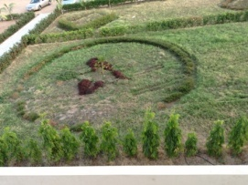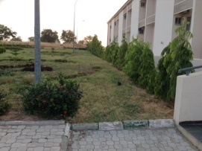 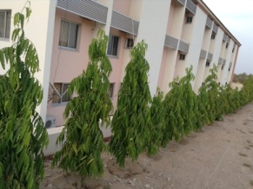 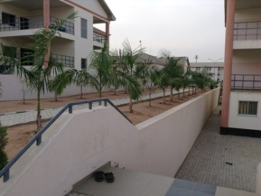

**RESIDENCE HALL AA – FAMOUS FOR ITS SUCCESS STORIES**

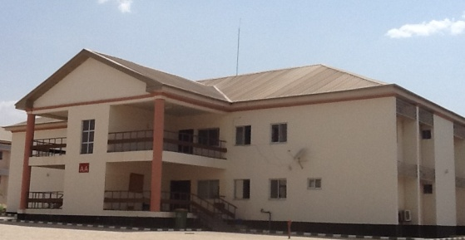The Fame of Residence Hall AA lies not with the building itself, but with the residents its houses. It is seen as the starting point for the residents and teaches them a variety of life related issues like knowing their aim and purpose in school, building their grades, managing their time, balancing their studies, school activities/events and their personal lives.  In 2013, it became the freshman dorm for girls and its residents always wish to be till their commencement. They see themselves as one big happy family despite their cultural differences, ethical group, background, belief, and a place where they see as their second home.   
In all things, honor must be given to whom it is due. The success of Residence Hall AA can only be attributed to its residents.  Be it the 2012 batch of freshmen or the 2013 intakes, they were all exceptional. They were always committed to be nothing but the best. They put in their time and energy into ensuring that they secure the first place in any competition. They are indeed, worthy of emulation.  Residence Hall AA has the capacity of Thirty two(32)rooms, Four(4)RAs, Two (2)Resident Directors, and its facilities are intact.

**Residence Hall BB**

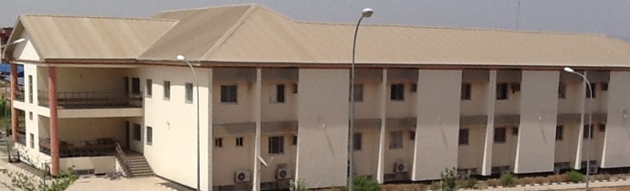Proudly known as the BEST Residence Hall in AUN and the first choice of students while on campus, BB stood out in a variety of both social and academic events. Winners of the 2013 homecoming variety show with outstanding award in community service and winning several medals during the SGA Olympic 2013, the Residence Hall is a point of attraction to many.

**RESIDENCE HALL CC**

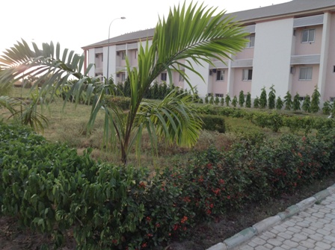Residence hall CC is located in the south (main) campus of American university of Nigeria Yola, has the capacity to accommodate eighty-six students (resident assistants inclusive) who are returning students. The residence hall is home like never before. There are 44 comfortable/cosy rooms, with well-functioning Air conditioners, comfortable beds, reading tables and beautiful reading lamps. In these rooms is a clean bathroom/toilet running with toiletries 24hours for your comfort.

This residence hall has hair salon as well, right at your feet and a beautiful blooming garden at the basement, a well-furnished common room with a cable TV showing your favorite series, sports, movies, news and more. spring fling, overall best of the recently concluded homecoming variety show! Honored with a community service award and more to come when you join us

Come, live with the champion!!!

**RESIDENCE HALL DD**

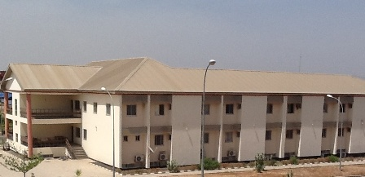Residence Hall DD (a girls dorm) is located on the Main Campus of the American University of Nigeria. It is graced with a beautiful view of the green plains of Adamawa State. It comprises of students of various academic years; ranging from second semester freshmen, sophomores, juniors and graduating students (seniors).

The residence hall provides a comfortable and conducive living environment for the students. It is made up of two floors which consist of thirty six (36) rooms and basement which consist of classes, labs and also instructors’ offices. The rooms are very conducive as they meet all the necessary requirements the students need to live a fulfilled academic life. Each room consist of three medium sized beds, bed side lamps positioned at each bed, an air conditioner, a reading table and four adequately shelved wardrobes each with its key. In the room, there is also a well facilitated bathroom which has a shower enclosed by a shower curtain, a sink and mirror, a water closet system toilet and water heater which provides hot water at all times.

 There is also a common room furnished with a television, DSTV connection, good sofas, air-conditioners, dispensers, refrigerator which provides a relaxing spot at leisure times for the residents. There is also a kitchen equipped with a microwave, sinks, water and sockets for cooking and also study room with air-conditioners, tables and chairs on each floor.

There are four trained Residence Life staff, Two RDs and two RAs who offers supervision on a 24 hours basis. They are trained to handle any emergency situations which might range from a health crisis to a dispute among the students. They also help in organizing events such as academic lectures, social events which improve the general living experience of the students and also promotes team work and interaction between the students.

**GABRIELE VOLPI RESIDENCE**

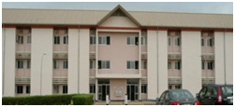Gabriele Volpi (Male Residence Hall) is located at the central base of the main campus. The hall is close to both the school cafeteria and class. The hall is the largest male Residence Hall on campus. It has three floors with a capacity of 162 Residents. The hall is supervised

or monitored by three Resident Directors and three Resident Assistant who are charged with the responsibility of protecting, guiding, instilling discipline and assisting Residents living in the residence Hall. Gabriele Volpi is so far the best Residence Hall in terms of facilities, social events, community service, sports, and lots of other extracurricular. It is the most competitive Residence Hall on campus . In Gabreile volpi, we have three different types of rooms, they includes two with facilities, three without facilities and two without facilities. Those without facilities have their general toilet at the extreme end on each floor.

When you are enrolled in AUN, let your choice of Residence Hall  be Gabriele Volpi

**ROSARIA ROPA VOLPI- ROYAL RESORT**.

Succumb to the overwhelming rhythm of *AUN’s Royal Resort –ROSARIA ROPA VOLPI RESIDENCE, and discover the true essence of residential comfort. It is the biggest and the best ever female residence hall. This fabulous façade is the first hall that meets the eyes of anyone coming down the road from A&S building, through commencement hall.*

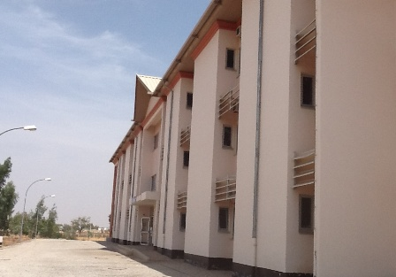It encompasses the best facilities, fabulous interiors, beautifully built courtyard where students hang out and dorm activities are been organized.

Comfortable air conditioned rooms with 2 occupants and 3 in some, the common rooms have nice couches and plasma TV where the residents stay together, watch educating programs and ease off stress. The kitchen has just enough space to make wonderful delicacies.

Talk about the girls? We have the best brains, academic giants that ultimately will lead the world. Our creative mind is unbeatable; in fashion we lead others follow. So graceful, heart full of gold, charismatic, charming, beautiful beyond looks, heart so tender and loving, charitable, smart, lovable, classic, and don’t forget “The Most Beautiful”. Despite the little differences in culture, tribe, religion, age etc., amazingly we all piece together to form a beautiful family portrait where tolerance love and care abides.